QCS
Regus House, Highbridge Industrial Estate, Oxford Road, Uxbridge, Middlesex, UB8 1HR, United Kingdom, Phone: TBA

GHS15 - Coronavirus Policy and Procedure
Category: Health and Safety Sub-category: Health & Safety

Policy Review Sheet
Page: 1 of 10 Last Reviewed: 11/03/2020 Last Amended: 11/03/2020

Last Reviewed: 13/03/20 Last Amended: 13/03/20

Next planned review in 12 months, or sooner as required.

Note: The full policy change history is available in your online management system.

Business Impact: | Low | Medium | High | Critical
 |  |  |  | X
Immediate action these changes are business critical and to be delivered as a matter of urgency.

Reason for this review: | New Policy
Were changes made? | Yes
Summary: | COVID-19 has been declared a pandemic by the Director General of the World Health Organisation on 11 March 2020. This policy should be used in conjunction with the Pandemic Policy and the Business Continuity Plan.
Relevant Legislation: | - The Health Protection (Coronavirus) Regulations 2020  - Civil Contingencies Act 2004  - Control of Substances Hazardous to Health Regulations 2002  - Equality Act 2010  - Health and Safety at Work etc. Act 1974  - Health and Social Care Act 2008 (Registration and Regulated Activities) (Amendment) Regulations 2015

QCS
Regus House, Highbridge Industrial Estate, Oxford Road, Uxbridge, Middlesex, UB8 1HR, United Kingdom, Phone: TBA

GHS15 - Coronavirus Policy and Procedure
Page: 2 of 10 Last Reviewed: 11/03/2020 Last Amended: 11/03/2020

Underpinning Knowledge - What have we used to ensure that the policy is current: | - UNICEF, WHO et al, (2020), Social Stigma associated with COVID-19. [Online] Available from: https://www.epi- win.com/sites/epiwin/files/content/attachments/2020-02-24/COVID19% 20Stigma%20Guide%2024022020_1.pdf [Accessed: 13/03/2020]  - Department of health and Social Care, (2020), Number of coronavirus (COVID-  19) cases and risk in the UK. [Online] Available from: https://www.gov.uk/guidance/wuhan-novel-coronavirus-information-for-the- public [Accessed: 13/03/2020]  - Public Health England, (2020), COVID-19: infection prevention and control. [Online] Available from: https://www.gov.uk/government/publications/wuhan- novel-coronavirus-infection-prevention-and-control [Accessed: 13/03/2020]  - Public Health England, (2020), COVID-19: guidance to assist professionals in advising the general public. [Online] Available from: https://www.gov.uk/government/publications/covid-19-stay-at-home-guidance [Accessed: 13/03/2020]  - Public Health England, (2020), COVID-19: background information. [Online] Available from: https://www.gov.uk/government/publications/wuhan-novel- coronavirus-background-information [Accessed: 13/03/2020]  - World Health Organisation, (2020), Coronavirus disease (COVID-19) advice for the public. [Online] Available from: https://www.who.int/emergencies/diseases/novel-coronavirus-2019/advice-for- public [Accessed: 13/03/2020]  - Pubic Health England, (2020), COVID-19: guidance for primary care. [Online] Available from: https://www.gov.uk/government/publications/wn-cov-guidance- for-primary-care [Accessed: 13/03/2020]  - NHS England and NHS Improvement, (2020), Preparedness letter for general practice: 10 March 2020. [Online] Available from: https://www.england.nhs.uk/coronavirus/wp- content/uploads/sites/52/2020/03/preparedness-letter-primary-care-10-march- 2020.pdf [Accessed: 13/03/2020]
Suggested action: | - Encourage sharing the policy through the use of the QCS App  - Establish process to check and confirm staff understanding of the policy  - Include discussion in staff handovers  - Ensure policy is on the agenda for all supervisions  - Hold specific meetings to discuss impact  - Display changes and impact in relevant places e.g. office, staff room, reception areas, kitchens etc.  - Ensure relevant staff are empowered to develop specific and individualised processes to share policy changes  - Share information quickly and widely  - Ensure all staff know about the policy changes

QCS
Regus House, Highbridge Industrial Estate, Oxford Road, Uxbridge, Middlesex, UB8 1HR, United Kingdom, Phone: TBA

GHS15 - Coronavirus Policy and Procedure
Page: 3 of 10 Last Reviewed: 11/03/2020 Last Amended: 11/03/2020

1. Purpose
  - To ensure that the practice remains up to date and is able to respond in the event of a member of staff, patient or contact, contracting the virus (SARS coronavirus-2 (SARS-CoV-2)) which results in the disease COVID-19.

  - To meet the legal requirements of the regulated activities that the practice is registered to provide:

    - The Health Protection (Coronavirus) Regulations 2020
    - Civil Contingencies Act 2004
    - Control of Substances Hazardous to Health Regulations 2002
    - Equality Act 2010
    - Health and Safety at Work etc. Act 1974
    - Health and Social Care Act 2008 (Registration and Regulated Activities) (Amendment) Regulations 2015

2. Scope
  - The following roles may be affected by this policy:

    - All staff
    - Senior Management

  - The following people may be affected by this policy:

    - Patients

  - The following stakeholders may be affected by this policy:

    - Family
    - Commissioners
    - External health professionals
    - Local Authority
    - NHS

3. Objectives
  - To ensure that safe, effective procedures are in place with staff and patients having information in an accessible format.
  - As the spread of the virus is resulting in response requirements changing daily, the practice will ensure that it stays up to date with reliable sources of information and has the flexibility to respond when required.

4. Policy
  - The practice recognises that the outbreak of a new strain of coronavirus SARS coronavirus-2 (SARS-CoV-
2) which results in the disease COVID-19 is a fast-moving situation. With the World Health Organisation (WHO) declaring this a pandemic on 11 March 2020 the practice understands that they must be preparing themselves. As healthcare providers, ensuring robust infection control and business continuity plans form part of preparing business at the practice for any events.

  - The practice will ensure that staff are aware and understand the importance of pandemic preparedness and will carry out preparations by following the checklist in the Pandemic Policy and Procedure at the practice. The practice understands that business continuity planning involves all aspects of the business and to be effective the practice must work with their partners, suppliers and commissioners to ensure that a safe and effective service can be maintained.

  - The practice understands that they have a responsibility for ensuring that staff follow good infection control and prevention techniques. The practice will ensure that staff have access to reliable information to reduce anxiety and dispel any myths and inaccurate information that may cause worry or distress to staff or patients.

QCS
Regus House, Highbridge Industrial Estate, Oxford Road, Uxbridge, Middlesex, UB8 1HR, United Kingdom, Phone: TBA

GHS15 - Coronavirus Policy and Procedure
Page: 4 of 10 Last Reviewed: 11/03/2020 Last Amended: 11/03/2020

5. Procedure
  - Pandemic Policy

The practice recognises that the WHO has declared COVID-19 as a public health emergency of international concern, known as a PHEIC. On 11 March 2020 this has been declared a pandemic by the Director General of the World Health Organisation (WHO). the practice however, will review the Pandemic Policy and Procedure and complete the checklist to ensure that the business is prepared and that robust business continuity plans are in place.

The practice will ensure that staff have access to the Coronavirus Fact Sheet within the Forms section of this document.

Reducing the Risk of Contracting or Spreading the Virus

The practice will ensure that staff follow the WHO advice to reduce the risk of contracting the virus and reducing the risk of spreading it. The following procedures must therefore be followed;

    - Wash your hands regularly and properly by using alcohol-based hand rub or soap and water
    - Maintain at least 1 metre (3 feet) distance between yourself and anyone who is coughing or sneezing (social distancing). When someone coughs or sneezes they spray small liquid droplets from their nose or mouth which may contain the virus. If you are too close, you can breathe in the droplets, including the COVID-19 virus if the person coughing has the disease
    - Avoid touching eyes, nose and mouth. Hands touch many surfaces and can pick up viruses. Once contaminated, hands can transfer the virus to your eyes, nose or mouth. From there, the virus can enter your body and can make you sick
    - Practice respiratory hygiene. Make sure you, and the people around you, follow good respiratory hygiene. This means covering your mouth and nose with your bent elbow or tissue when you cough or sneeze. Then dispose of the used tissue immediately. Droplets spread virus. By following good respiratory hygiene you protect the people around you from viruses such as cold, flu and COVID-19
    - The most common symptoms of coronavirus (COVID-19) are recent onset of a new continuous cough and/or high temperature. If patients or staff members have these symptoms, however mild, they must stay at home and do not leave the house for 7 days from when the symptoms started. They do not need to call NHS 111 to go into self-isolation. If their symptoms worsen during home isolation or are no better after 7 days, they should contact NHS 111 online. If they do not have internet access, they should call NHS 111. For a medical emergency dial 999.
    - If you have a fever, cough and difficulty breathing, seek medical care early. Stay home if you feel unwell. If you have a fever, cough and are having difficulty breathing, seek medical attention by calling 111. Do not go directly to your GP or hospital. Why? 111 will have the most up-to-date information on the situation. Calling in advance will allow 111 to direct you quickly to the right health facility. This will also protect you and help to prevent the spread of viruses and other infections
    - Stay informed and follow advice given by 111 or Public Health England. National and local authorities will have the most up-to-date information on whether COVID-19 is spreading in your area. They are best placed to advise on what people in your area should be doing to protect themselves
    - People who feel unwell should stay at home and should not attend work

Handwashing

Staff should wash their hands:

    - Before leaving home
    - On arrival at work
    - After using the toilet
    - After breaks and sporting activities
    - Before food preparation
    - Before eating any food, including snacks
    - Before leaving work
    - On arrival at home

Confidentiality

The practice will follow confidentiality and GDPR policies and procedures to ensure that the details of staff
and patients with suspected or confirmed COVID-19 is kept confidential. Employees should also respect

QCS
Regus House, Highbridge Industrial Estate, Oxford Road, Uxbridge, Middlesex, UB8 1HR, United Kingdom, Phone: TBA

GHS15 - Coronavirus Policy and Procedure
Page: 5 of 10 Last Reviewed: 11/03/2020 Last Amended: 11/03/2020

each other’s confidentially and take care not to inadvertently share information when using social media.

Where staff are suspected or confirmed to have contracted COVID-19, their personal details should be treated as confidential, as they would be for any other the practice patients.

Safe Staffing

In the event of an outbreak of COVID-19, where staff are moved from other areas to support work on COVID-19, assessments should be made on the ability to continue to deliver safe and effective care in the services affected. Steps should be taken to mitigate any risks resulting from staff moving to other areas.

Reducing the Risk of Stigmatisation

Stigma occurs when people negatively associate an infectious disease, such as COVID-19, with a specific population. In the case of COVID-19, there are an increasing number of reports of public stigmatisation against people from areas affected by the epidemic, this means that people are being labelled, stereotyped, separated, and/or experience loss of status and discrimination because of a potential negative affiliation with the
disease. The practice will ensure that staff understand the importance of preventing and addressing social stigma by making sure facts are available to staff and patients.

Identifying Possible Cases of the Virus

Returning travellers

Patients may need to get medical advice if they have recently travelled to the UK from somewhere with a higher risk of coronavirus in the last 14 days. They should stay indoors and avoid contact with other people if they have travelled to the UK from the following places, even if they do not have symptoms:

    - Anywhere in Italy on or after 9 March
    - Specific areas in northern Italy in the last 14 days
    - Iran in the last 14 days
    - Hubei province in China in the last 14 days
    - Daegu, Cheongdo or Gyeongsan in South Korea in the last 14 days

Stay indoors and avoid contact with other people if they have travelled to the UK from the following places in the last 14 days and have a cough, high temperature or shortness of breath, even if symptoms are mild:

    - Italy (outside specific areas in northern Italy) before 9 March
    - Mainland China outside of Hubei province
    - South Korea outside of Daegu, Cheongdo and Gyeongsan
    - Cambodia
    - Hong Kong
    - Japan
    - Laos
    - Macau
    - Malaysia
    - Myanmar
    - Singapore
    - Taiwan
    - Thailand
    - Vietnam

Patients should use the 111 online coronavirus service to find out what to do next. They must not go to a GP surgery, pharmacy or hospital.
See COVID-19: specified countries and areas for more information and maps of specific areas. Specific areas in northern Italy:
    - Lombardy region (which includes the cities of Milan, Bergamo and Como)
    - The provinces of Modena, Parma, Piacenza, Reggio Emilia and Rimini (all in Emilia Romagna)
    - Pesaro e Urbino (in Marche)
    - Alessandria, Asti, Novara, Verbano-Cusio-Ossola and Vercelli (all in Piemonte)

QCS
Regus House, Highbridge Industrial Estate, Oxford Road, Uxbridge, Middlesex, UB8 1HR, United Kingdom, Phone: TBA

GHS15 - Coronavirus Policy and Procedure
    - Padova, Treviso and Venice (in Veneto)
Page: 6 of 10 Last Reviewed: 11/03/2020 Last Amended: 11/03/2020

    - This list is changing every day and the practice will keep under review the specific advice for each country by reviewing the Public Health England Web pages on returning travellers to the UK. The practice will also review the number of cases reported to keep up to date on the risk which is updated daily
at 2pm on the Public Health England site

Definition of Contact

Contact with a case is defined as any of the following:
    - Living in the same household
    - Direct contact with the case or their body fluids, or in the same room of a healthcare setting when an aerosol generating procedure is undertaken on the case without appropriate PPE
    - Direct or face to face contact with a case, for any length of time
    - Being within 2 metres of the case for any other exposure not listed above, for longer than 15 minutes
    - Being otherwise advised by a public health agency that contact with a confirmed case has occurred
    - Contacts are not considered cases and if they are well they are very unlikely to spread the infection to others

Actions if a Patient Meets the Criteria and Displays Symptoms

If a patient arrives at the practice complaining of symptoms and meets the criteria above from either travelling or contact with others, staff must make sure;

    - The patient is isolated safely and staff should withdraw from the room
    - They immediately wash their hands and avoid touching the face, nose, mouth or eyes
    - They contact 999 if an emergency (if they are seriously ill or injured or their life is at risk) and explain which country they have returned from in the last 14 days and outline their current symptoms
    - Whilst they wait for an ambulance to arrive, staff should remain at least 2 metres from other people. They should avoid touching people, surfaces and objects and be advised to cover their mouth and nose with a disposable tissue when they cough or sneeze and put the tissue in a bag then throw the tissue in the bin. If they do not have any tissues available, they should cough and sneeze into the crook of their elbow
    - If they need to go to the bathroom whilst waiting for medical assistance, they should use a separate bathroom if available. This will apply only to the period of time while waiting for transport to hospital

Action if a Member of Staff Reports Symptoms

    - The practice will ensure that the member of staff self isolates
    - Advice must be sought on what action will need to take place for any patients that they may have had contact with
    - If a member of staff reports that there are concerns about their children, close family, friends who they have had close contact with they must again self isolate
    - The practice must ensure that confidentiality is maintained and that records are held in line with Data Protection Act requirements
    - In the event of a confirmed case, closure of the office or workplace is not recommended. The practice will be contacted by the Public Health England (PHE) local Health Protection Team to discuss the case, identify people who have been in contact with them and advise on actions that should be taken

Cleaning the Office and Workplace Where There are Confirmed Cases of COVID-19

Coronavirus symptoms are similar to a flu-like illness and include cough, fever, or shortness of breath. Once symptomatic, all surfaces that the person has come into contact with must be cleaned including:

    - All surfaces and objects which are visibly contaminated with body fluids
    - All potentially contaminated high-contact areas such as toilets, door handles, telephones
    - Clothing and linen used by the person should be set aside pending assessment of the person by a healthcare professional

Public areas where a symptomatic individual has passed through and spent minimal time in (such as corridors) but which are not visibly contaminated with body fluids do not need to be specially cleaned and disinfected.

Rubbish Disposal Including Tissues

    - All waste that has been in contact with the individual, including used tissues should be put in a plastic

QCS
Regus House, Highbridge Industrial Estate, Oxford Road, Uxbridge, Middlesex, UB8 1HR, United Kingdom, Phone: TBA

GHS15 - Coronavirus Policy and Procedure
Page: 7 of 10 Last Reviewed: 11/03/2020 Last Amended: 11/03/2020

rubbish bag and tied. The plastic bag should then be placed in a second bin bag and tied. It should be put in a safe place and marked for storage until the COVID-19 test result is available, which will be within 24 hours
    - If the individual tests negative, this can be put in the normal waste
    - Should the individual test positive, the local Health Protection Team advise you what to do with the waste

Raising Concerns

The practice has effective procedures in place to allow staff to raise any concerns in relation to equipment, policies and processes for managing COVID-19 at the earliest opportunity. All staff must be aware of the Whistleblowing Policy and Procedure at the practice and be able to raise concerns without any fear and receive timely feedback on their concerns.

6. Definitions
  - Pandemic

    - A pandemic is the worldwide spread of a new disease

World Health Organisation

    - The World Health Organisation (WHO) is a specialised agency of the United Nations that is concerned with world public health

COVID-19

    - Novel coronavirus is a new strain of coronavirus first identified in Wuhan City, China. The virus was named severe acute respiratory coronavirus 2 (SARS-CoV-2). The disease it causes is called COVID-19

Outbreak

    - A disease outbreak is the occurrence of disease cases in excess of normal expectancy. The number of cases varies according to the disease-causing agent, and the size and type of previous and existing exposure to the agent

Social Stigma

    - Social stigma in the context of health is the negative association between a person or group of people who share certain characteristics and a specific disease. In an outbreak, this may mean people are labelled, stereotyped, discriminated against, treated separately, and/or experience loss of status because of a perceived link with a disease. Such treatment can negatively affect those with the disease, as well as their caregivers, family, friends and communities. People who do not have the disease but share other characteristics with this group may also suffer from stigma. The current COVID-19 outbreak has provoked social stigma and discriminatory behaviours against people of certain ethnic backgrounds as well as anyone perceived to have been in contact with the virus

The Health Protection (Coronavirus) Regulations 2020

    - The Health Protection (Coronavirus) Regulations 2020 was put in place with immediate effect on 25th February 2020 to impose restrictions on any individual considered by health professionals to be at risk of spreading the virus

    - The regulations apply to any individuals seeking to leave supported isolation before the current quarantine period of 7 days is complete. It will also apply to future cases during the current coronavirus incident where an individual who may be infected or contaminated could present a risk to public health

QCS
Regus House, Highbridge Industrial Estate, Oxford Road, Uxbridge, Middlesex, UB8 1HR, United Kingdom, Phone: TBA

GHS15 - Coronavirus Policy and Procedure

Key Facts - Professionals
Page: 8 of 10 Last Reviewed: 11/03/2020 Last Amended: 11/03/2020

Professionals providing this service should be aware of the following:

- The practice must make sure they have the facts about the new coronavirus or the disease COVID-19 from a reliable source. Public Health England and the Department of Health and Social Care are 2 examples. Staff should read the fact sheet in the Forms section for more information
- The practice must have an up to date business continuity plan in place. The Pandemic Policy and Procedure has a checklist to help plan for an outbreak of a disease like COVID-19
- It is important that patients are made aware of how they can help limit the spread of COVID-19 and that they understand the signs and symptoms of the disease
- The practice will need to work closely with the Clinical Commissioning Group (CCG), other health providers, suppliers and other agencies to ensure that there is continuity and consistency of care
- The current understanding is that the virus does not survive on surfaces for longer than 72 hours. Regular cleaning of frequently touched hard surfaces and hands will therefore help to reduce the risk of infection
- Washing your hands often, with soap and water, or use alcohol sanitiser that contains at least 60% alcohol if handwashing facilities are not available - this is particularly important after taking public transport

Key Facts - People Affected by The Service

People affected by this service should be aware of the following:

- A coronavirus is a type of virus. Coronaviruses are common across the world. Typical symptoms of coronavirus include fever and a cough that may progress to severe pneumonia causing shortness of breath and breathing difficulties. This new virus is called SARS coronavirus-2. The disease it causes is called COVID-19
- There is no vaccine at the moment for this virus. Washing your hands regularly with soap and water will help prevent the spread of the disease. Try not to touch your eyes, nose and mouth with unwashed hands
- Its ok to feel worried or anxious. The practice has plans in place to make sure you will get the care that you need
- Washing your hands often, with soap and water, or use alcohol sanitiser that contains at least 60% alcohol if handwashing facilities are not available - this is particularly important after taking public transport

Further Reading

As well as the information in the 'Underpinning Knowledge' section of the review sheet we recommend that you add to your understanding in this policy area by considering the following materials:

Public Health England Blog:

https://publichealthmatters.blog.gov.uk/2020/01/23/wuhan-novel-coronavirus-what-you-need-to-know/ Preparedness letters for General Practice https://www.england.nhs.uk/coronavirus/publication/preparedness-letters-for-general-practice/

QCS
Regus House, Highbridge Industrial Estate, Oxford Road, Uxbridge, Middlesex, UB8 1HR, United Kingdom, Phone: TBA

GHS15 - Coronavirus Policy and Procedure

Outstanding Practice
Page: 9 of 10 Last Reviewed: 11/03/2020 Last Amended: 11/03/2020

To be ‘Outstanding’ in this policy area you could provide evidence that:

- The wide understanding of the policy is enabled by proactive use of the QCS App
- The practice has robust infection control policies and procedures in place and staff understand the importance of good hand hygiene, how to use personal protective equipment appropriately and they share their knowledge with patients appropriately
- Staff have accurate and up-to-date information and the practice is able to respond quickly and safely to a fast- changing situation
- The practice has shared its pandemic and business continuity plan and everyone knows what their roles and responsibilities are
- The practice has additional information on their text message confirmations directing patients to check the latest situation before attending the practice

Forms

The following forms are included as part of this policy:

Title of form | When would the form be used? | Created by
Coronavirus Fact Sheet | To share information with staff or patients | QCS

QCS
Regus House, Highbridge Industrial Estate, Oxford Road, Uxbridge, Middlesex, UB8 1HR, United Kingdom, Phone: TBA

Coronavirus Policy and Procedure
Page: 10 of 10 Last Reviewed: 13/03/2020 Last Amended: 13/03/2020

This page is deliberately left blank

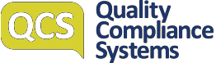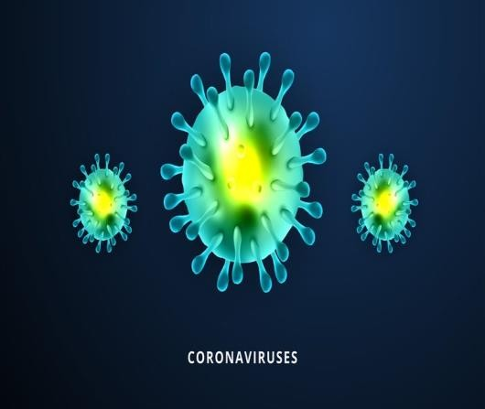
March 2020 v2.0

Coronavirus Fact Sheet

Coronavirus ~ COVID-19

What is it?

COVID-19 is a new illness that can affect your lungs and airways. It's caused by a virus called coronavirus. This new coronavirus started in Hubei Province, China. The coronavirus causes a disease which is called COVID-19
COVID-19 Key Facts

- The disease can spread from person to person through small droplets from the nose or mouth which are spread when a person with COVID-19 coughs or exhales. These droplets land on objects and surfaces around the person
- You must not go to A&E if you are unwell and think you may have COVID-19
- You must use the 111 Coronavirus service or call 111
- Good hand hygiene is one of the best ways of preventing the spread of the virus
•
•
Cough etiquette helps too
It is not certain how long the
virus that causes COVID-19 survives on surfaces, but it seems to behave like other coronaviruses. But it may last on some surfaces for a few hours or up to several days
While coronavirus is of concern, it is important to remember that most people displaying symptoms such as fever, cough, sore throat or tiredness are likely suffering with a cold or other respiratory illness, not coronavirus .

How is it spread?
The coronavirus is most likely to spread from person-to-person through:
- Direct close contact with a person while they are infectious;
- Close contact with a person with a confirmed infection who coughs or sneezes, or;
- Touching objects or surfaces (such as door handles or tables) contaminated from a cough or sneeze from a person with a confirmed infection, and then touching your mouth or face.

How can we help stop it spreading?
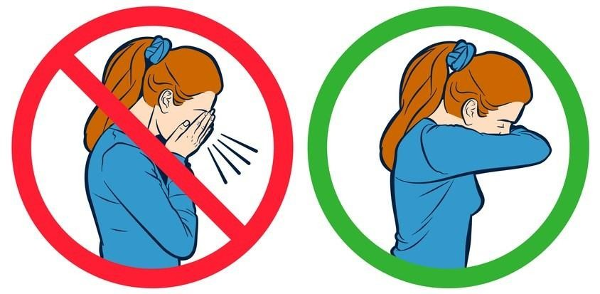
Practising good hand and sneeze/cough hygiene is the best defence against most viruses. You must:

Wash your hands frequent- ly with soap and water, be- fore and after eating and after going to the toilet
Cover your cough and sneeze, dispose of tissues and use alcohol-based hand
-sanitiser. If you don’t have
a tissue, use your sleeve.
If unwell, avoid contact with others (touching, kissing, hugging etc.)

‘Based on the World Health Organization’s declaration that this is a public health emergency of interna- tional concern, the UK Chief Medical Officers have declared COVID-19 a pandemic.’ NHS Website March 2020

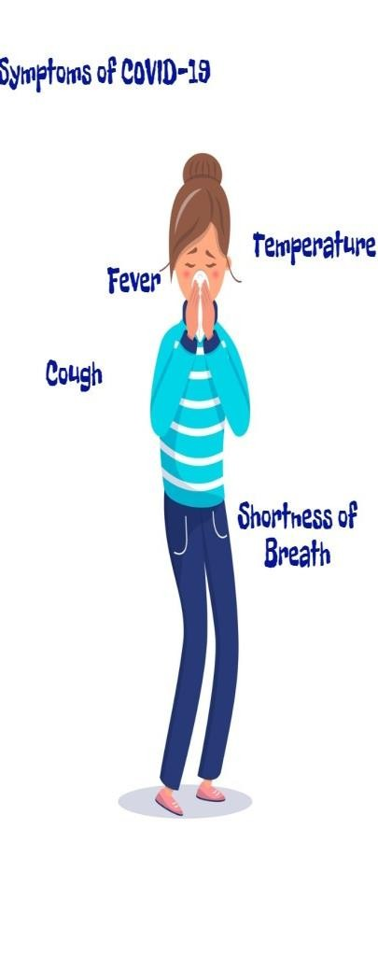What should I do if I have travelled?
Stay indoors and avoid contact with other people if you’ve travelled to the UK from the following places in the last 14 days, even if you do not have symptoms:
  - Iran
  - Hubei province in China
  - lockdown areas in northern Italy
  - special care zones in South Korea
Stay indoors and avoid contact with other people if you’ve travelled to the UK from the following places in the last 7 days and have a cough, high tempera- ture or shortness of breath, even if your symptoms are mild:
  - mainland China outside of Hubei province, Italy outside of the lockdown areas, South Korea outside of the special care zones ,Cambodia,Hong Kong, Japan ,Laos,Macau,Malaysia,Myanmar,Singapore,Taiwan,Thailand,Vietnam

ACAS Guidance for Employers and Employees
Which Policies Do I Need?
♦
♦
♦
♦
Business Continuity
Infection Control

Pandemic Sickness Absence
♦
Unable to Attend the Work-
place
♦
♦
Compassionate Leave
Bereavement Policy
- keep everyone updated on actions being taken to reduce risks of exposure in the workplace
- make sure everyone's contact numbers and emergency contact details are up to date
- make sure managers know how to spot symptoms of coronavirus and are clear on any relevant processes, for ex- ample sickness reporting and sick pay, and procedures in case someone in the workplace develops the virus
- make sure there are clean places to wash hands with hot water and soap, and encourage everyone to wash their hands regularly
- provide hand sanitiser and tissues for staff, and encourage them to use them
- use PPE provided by NHS England
- consider if any travel planned to affected areas is essential
- Employers must not single anyone out. For example, they must not treat an employee differently because of their race or ethnicity.

Sick Pay
- The workplace's usual sick leave and pay entitlements apply if someone has coronavirus.
SSP will start on day 1 as agreed by the government
- Employees should let their employer know as soon as possible if they're not able to go to work.
- Check out the ACAS website for information on what you should do with pay if an employee has to self-isolate.
- Self certification should be carried out for the first 7 days
- References can be provided by 111 (not GP for this purpose)

Myth Busting

  - The new coronavirus can be transmitted through goods made in China or any country reporting COVID- 19 cases.
A : Its unlikely, however washing your hands is always a good idea

  - Hand dryers are effective at killing the virus?
A:No. Hand dryers are not effective in killing the 2019-nCoV.

  - Pets at home spread the new coronavirus (2019- nCoV)?
A: At present, there is no evidence that animals/pets such as dogs or cats can be infected with the new coronavirus.

QUESTION? | What about a close family member ?
Do I need to wear a face | You need to use the 111
mask? | Coronavirus Service to find
- It is not necessary to  wear a face mask if you | out what you need to do. You
are well. | do not necessarily need to
QUESTION? | stay away from work or
Someone at my partner’s | school if someone you live
work has been confirmed | with has recently come from
as having coronavirus,.  What should I do? | a country or area with a high
The only people who may | coronavirus risk.
need to stay away from | There is currently no vaccine to prevent Novel Coronavirus. The best way to prevent infection is to avoid being exposed to the virus.
school, work or university
are:
- people with confirmed
coronavirus | What is self-isolation?  If the worker is required to self-isolate, then they should be advised to remain at home for 7 days following last exposure and avoid close contact with other people as much as possible. Advise that they:  - Avoid having visitors  - Ask friends, family or delivery services to drop off any food or medicines that they might need/run other errands on their behalf  - Don’t go to work, school or public areas  - Don’t use taxis or public transport  - Don’t go to the GP practice or A&E
- people who have been in
close contact with some-
one with confirmed
coronavirus
- people who have been to
a country or area with a
high risk of coronavirus
in the last 14 days – see
our coronavirus advice
for travellers
- Otherwise, you should
continue to go to school,
university and work as
normal.
- You can use the NHS 111
online coronavirus ser-
vice to find out what to
do.
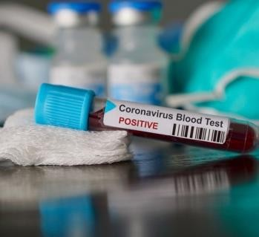

What action do I need to take now?
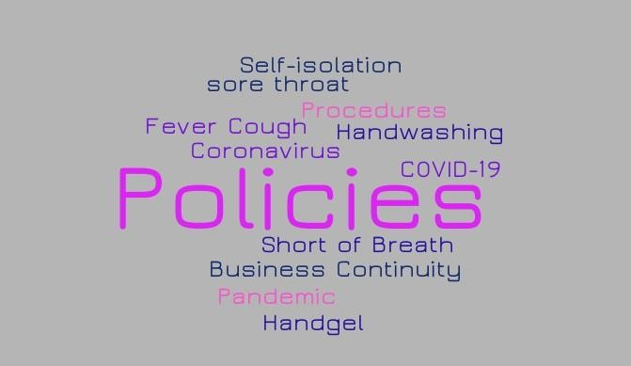
    - Check your Business Continuity Plan

    - Complete an action plan if there are any gaps

    - Complete your pandemic checklist – how prepared are you?

    - Check your staff Files – Who is at Risk?

    - Contact your Clinical Commissioning Group – what is the local plan?

    - Make sure you have communicated your policies and procedures
    - Make sure your infection control training is up to date

    - Keep your staff and patients up to date

Handwashing Techniques to Stay Healthy

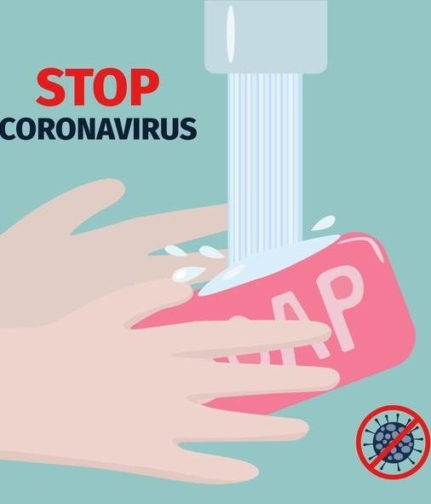Follow these five steps every time.

- Wet your hands with clean, running water (warm or cold), turn off the tap, and apply soap.
- Lather your hands by rubbing them together with the soap. Lather the backs of your hands, between your fin- gers, and under your nails.
- Scrub your hands for at least 20 seconds. How long? Hum
the “Happy Birthday” song from beginning to end twice.
- Rinse your hands well under clean, running water.
- Dry your hands using a clean towel or air dry them.

5

Useful Contacts

Quality Compliance Systems

Quality Compliance Systems (QCS) is the leading compliance management system for the Care sector. Our service provides over 70,000 Care, Dental and Medical professionals with access to the most comprehensive set of customised policies, procedures and compliance toolkits, enabling our users to stay compliant with current CQC policies. Over 2,700 dedicated pages are reviewed and updated regularly in line with legislative and regulatory requirements, and Best Practice guidelines, by our team of experts.
  - Out of Hours Clinical Advice: 111 for personal use or the 111 Coronavirus Service
  - Public Health England: 020 8200 4400 (professional use only)
  - You can also contact your local office. The details are on the website:
https://www.gov.uk/guidance/emergency-contacts-

Useful Websites

- 111 Coronavirus Service https://111.nhs.uk/covid-19

- Coronavirus Action Plan https://www.gov.uk/government/publications/ coronavirus-action-plan

- Government plans to support health and social care system in fightagainst COVID– 19 https://www.gov.uk/government/news/government-outlines- further-plans-to-support-health-and-social-care-system-in-fight-against-covid-19

- Coronavirus Myth Busters https://www.who.int/emergencies/diseases/novel- coronavirus-2019/advice-for-public/myth-busters

- COVID-19: interim guidance for primary care https://www.gov.uk/government/publications/wn-cov-guidance-for-primary- care/wn-cov-interim-guidance-for-primary-care

- NHSEI Preparedness letter for general practice: 10 March 2020 https://www.england.nhs.uk/coronavirus/wp- content/uploads/sites/52/2020/03/preparedness-letter-primary-care-10-march- 2020.pdf

Quality Compliance Systems Have a question?

0333 405 33 33
INFO@QCS.CO.UK WWW.QCS.CO.UK
This document is Copyright © Quality Compliance Systems Ltd. 2020 (Last updated 2020)

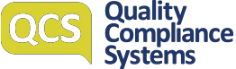

Coronavirus Fact Sheet

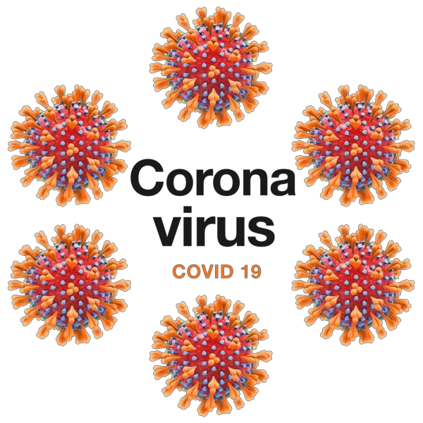

This factsheet will tell you about Coronavirus.

What is Coronavirus?

There is a new virus spreading. It's name is Coronavirus . It causes an illness called COVID-19. It started in China and is spreading across the world.

The illness makes people cough and have problems breathing. Some people have died but most people recover ok.

You can help to stop the virus spreading and do things that will keep you well.

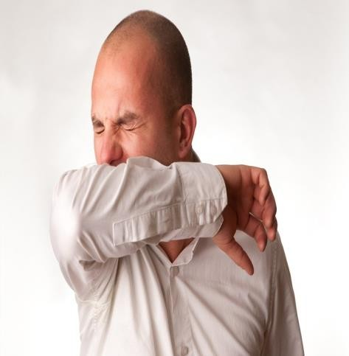
Cover your mouth and nose with a tissue or your sleeve (not your hands) when you cough or sneeze.

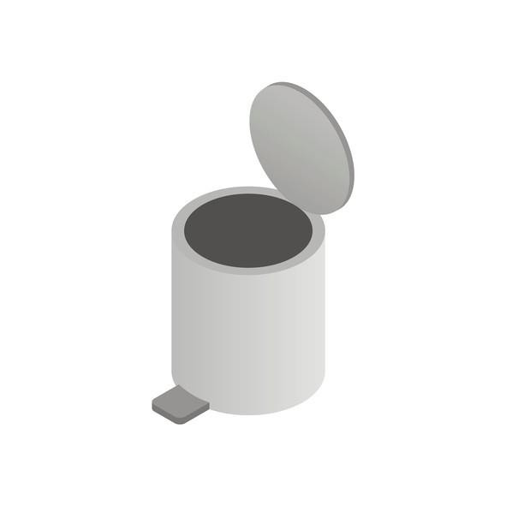
How to keep well

Put used tissues in the bin. Do not use your hands to close the bin lid.

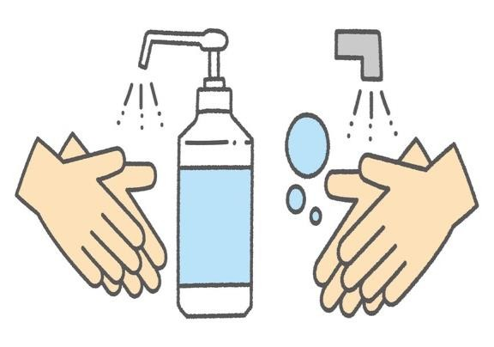
Wash your hands with soap and water often – use hand sanitiser gel if soap and water are not available.

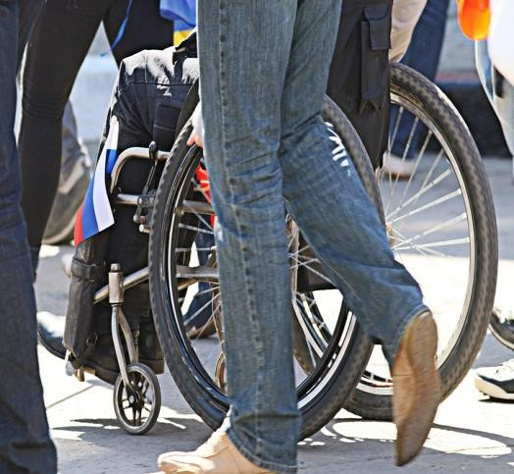
Avoid close contact with people who are unwell. Try to avoid crowds.

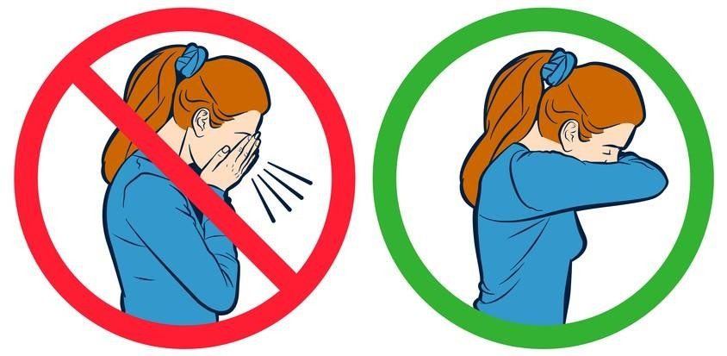
Do not touch your eyes, nose or mouth if your hands are not clean.

Feeling unwell

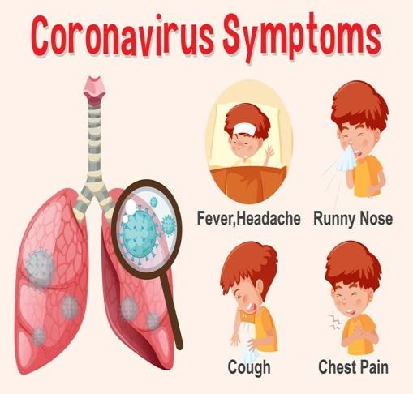
You may have a cough, a temperature, be short of breath. These are called symptoms.

There are countries in the world that have more people with coronavirus. People who have travelled to these countries in the last 14 days may get Coronavirus.

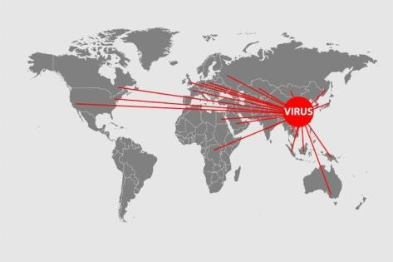
The main countries are Cambodia Iran, China, Daegu or Cheongdo Republic of Korea,
Hong Kong, Italy, Japan, Laos, Macau, Malaysia, Myanmar, Republic of Korea,Singapore,Taiwan,Thailand, Vietnam.

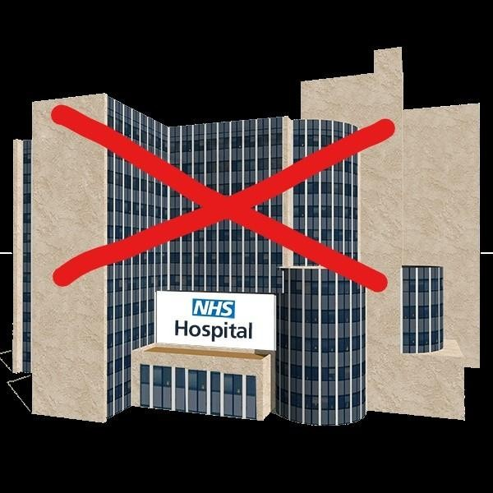
Feeling unwell

Do not go to the hospital unless the Doctor or Nurse says its ok to go.

You can check your symptoms on the NHS111 website https://111.nhs.uk/covid-19

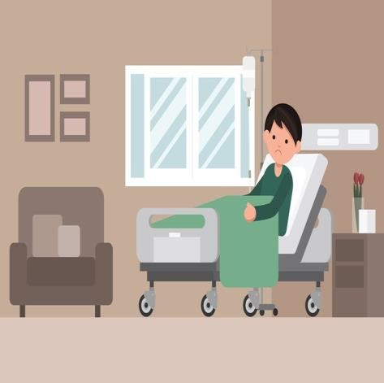
If you are already sick with heart or breathing problems, or you have diabetes, Coronavirus might make you very ill.

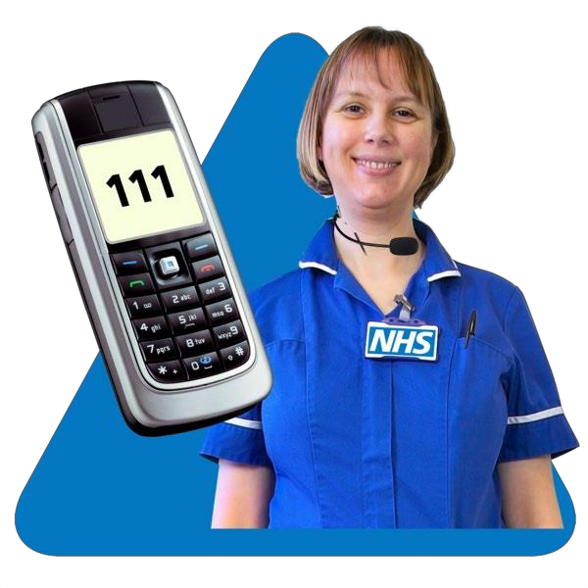
Call NHS 111 if you think you have Coronavirus.
- Tell them what symptoms you have.
- Tell them if you have other health problems.
- Tell them if you think you have been near someone who has the virus.

Feeling worried

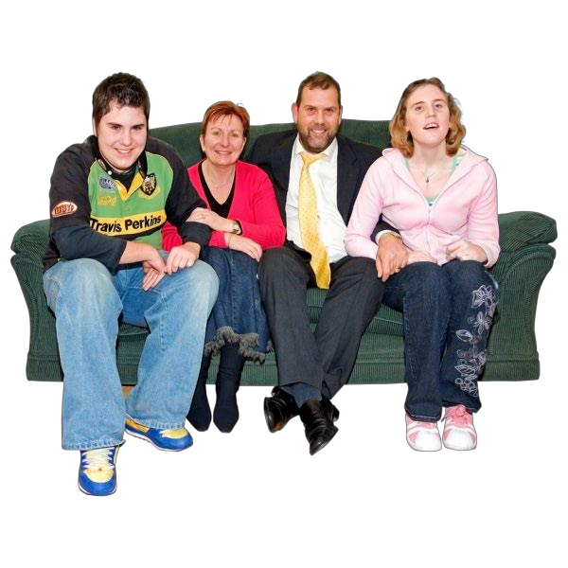

Its ok to be worried or scared.

Talking to people you trust can help. Contact your friends and family.

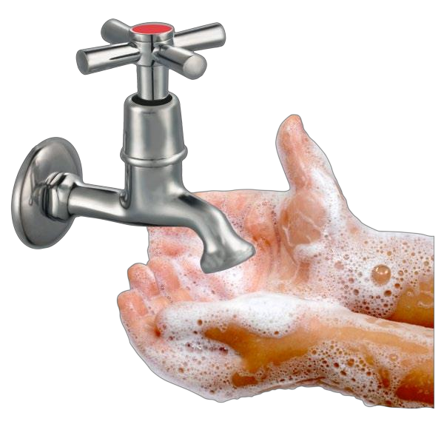
There are lots of people talking about Coronavirus. Sometimes it is hard to know what information is true. You can read correct information on the NHS website WWW.NHS.CO.UK

The most important thing to remember is to wash your hands lots of times in the day, even if they do not look dirty.

Useful Information

Make sure you keep healthy by eating lots of fruit and vegetables.

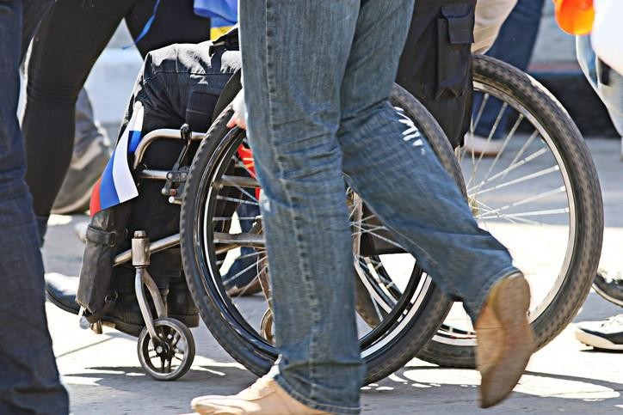
Stay away from crowds of people.

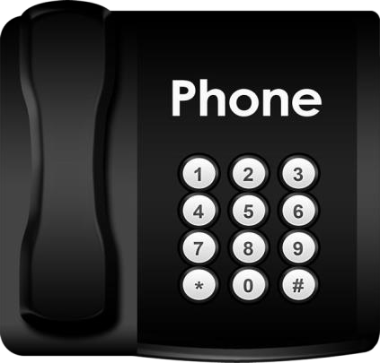
Call NHS 111 if you are unwell.

This document is Copyright © Quality Compliance Systems Ltd. 2020 (Last updated 2020)

This page is deliberately left blank

